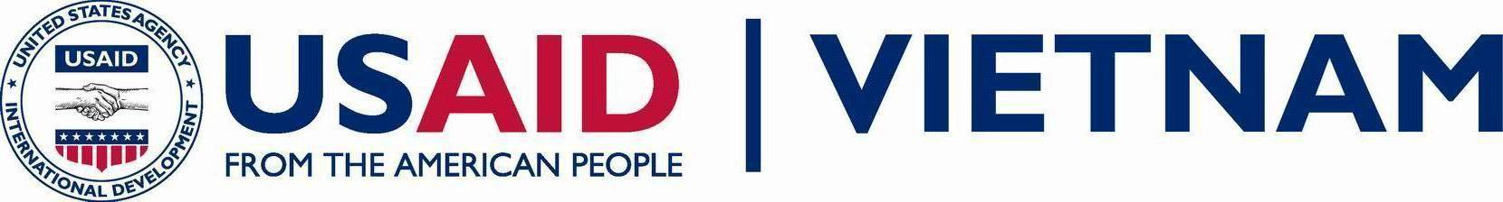
Event Form

Required for public events (remarks, speeches, & public appearances) where
USAID or U.S. Government representative participation is requested
Submit to USAID Communications Team and AOR/COR at least two weeks prior to the event.

PROJECT NAME: | AOR/COR:
EVENT: | DATE/TIME:
Organizer/Point of Contact:  Tel: Cell Phone:  E-Mail: | Location:
What does USAID hope to accomplish through this activity?  Will there be an opportunity to interact with direct beneficiaries? How? | Key Participants and Other Speakers:
ROLE OF U.S. GOVERNMENT REPRESENTATIVE (double-click on box to check any that apply)
Opening/Welcoming Remarks Brief Remarks Media Q & A No Speaking Role
Speech Audience Q & A Other:
MEDIA PRESENCE | LANGUAGE
Media Present No Media Present  Print:  TV (live or taped?):  Radio:  Wire Services:  Ground Rules  On the Record Off the Record Background  Media Participation in Q&A No Media in Q&A | Language Used by Other Speakers:  Working Language:  Translation Provided : Yes No  Simultaneous Translation  OR  Consecutive Translation  Translator Requested: Yes No
SCENARIO DETAILS (please attach event agenda)
Audience Description (size, ages, background, language ability, high level participants – by name): | Remarks to be delivered:  Seated Standing Behind Podium  Other (please describe):  Seating:  Head Table Front Row
SETUP PROVIDED
Podium with Microphone Handheld Microphone
Podium without Microphone Lapel Microphone
Free Standing Microphone Other (please describe):
Backdrop
Other Important Information:

Upon approval, additional materials to be submitted to USAID Communications Specialists and AOR/COR are: brief project background, talking points (if necessary). USAID Communications Specialists will provide due dates for these documents.

